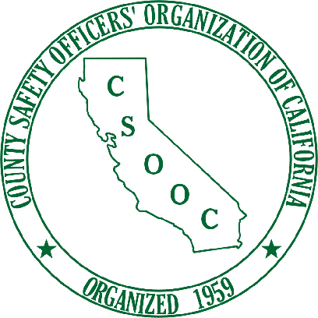
COUNTY SAFETY OFFICER’S
ORGANIZATION OF CALIFORNIA
2018 Annual Membership
Federal Tax ID # 77-0269489
Name and Title of Member: _________________________________________
County Name and Address _________________________________________
_________________________________________
Phone & Fax Numbers: _________________________________________
Email Address: _________________________________________
PLEASE REMIT YOUR COUNTY MEMBERSHIP FEE IN THE AMOUNT OF $200.00
Make checks payable to “CSOOC”
Mail to: Phil Raba, CSOOC Treasurer
County of Ventura L#1600
800 South Victoria Ave.
Ventura, Ca. 93009
Phone: (805) 650-4074 Fax: (805) 654-3952
E-mail: phil.raba@ventura.org
______ Membership Renewal _____New membership
Name and Title of Member: _________________________________________
County Name and Address _________________________________________
_________________________________________
Phone & Fax Numbers: _________________________________________
Email Address: _________________________________________
_____ I would like a receipt for payment.

